The Essence of Music
Joshua Garber, Baron Dolletski-Lazar, Nelson Tan

Dept. of Electrical Engineering and Computer Science, University of Central Florida, Orlando, Florida, 32816-2450 (12 point Times font)

Abstract — Essence of Music is a user-friendly device that takes audio from a handheld device and transforms it into a visual representation of the analog signals that it receives. The device utilizes several pre-made components while also making use of designed circuits in order to generate a system that is capable of interpreting the data. The system uses the Atmega328p and the Arduino IDE in order to store the code that will be used to interpret the data. The code makes use of 3 patterns that take advantage of the Adafruit libraries to manipulate a 16x32 Medium L.E.D grid which displays the patterns.

Index Terms — Active Circuits, Analog Processing Circuits, Breadboard Circuit, Microcontroller.

I. Introduction
Designed to allow users to experience music through designs that appeal to one’s sight, the Essence of Music is a simple machine that interprets incoming audio signals and produces a visual light show consisting of various types of patterns. The project utilizes a standard Bluetooth audio receiver in order to read in audio signals from a handheld device which are then routed to a commercial audio splitter which sends the signals to the stereo speaker system and the TL082 audio amplifier. The amplified audio is then passed to passed to the Atmega328p which has been loaded with original code to interpret incoming analog signals. The audio signals are read in by the 20 MHz device and passed to the code which uses the outgoing digital pins to manipulate the 512 L.E.Ds on the Adafruit 16x32 LED Matrix Panel. The system is internally powered by several different battery systems while the user will only have to worry about using a standard wall charger to power the L.E.D panel. The device is encased in a metal case with two peripherals for the user to interact with. The first peripheral is a button that allows the user to manipulate the active pattern on the L.E.D display while the second is a button that resets the device in the case of an unexpected crash. The device is designed to provide the users with a compact device that they can use to brighten up a room. It is controlled in tandem by the handheld device that they opt to use so long as it is able to connect to a Bluetooth brand receiver.

II. System Safety Requirements
As the Essence of Music device is a portable music device that also produces a visual light, there are some key safety requirements that need to be met. The first major safety issue that has to be addressed is the sound level that is produced from the device. We want the device to produce a sound that can be heard from a distance of 8 meters. However, we do not want to produce a sound that has the potential to cause permanent damage to one’s hearing known as Noise Induced Hearing Loss without having fully informed the user of risks to their hearing [1]. NIHL becomes a risk when the noise levels exceed 85 dB. Higher decibel values can induce damage to one’s hearing, but 85 dB is the threshold for the start of NIHL. This is done by letting the user know when noise levels exceed a certain level through a message that appears on the handheld device screen. Preventing the device from producing sounds that exceed the danger threshold is not possible due to the handheld device and the speakers controlling two aspects of the sound levels.
The second issue that must be addressed is the brightness settings of the L.E.Ds on the device. Retinal damage to the user can occur when the retinas are exposed to a bright light source for an extended period of time [2]. In particular, exposure to bright blue lights can also increase the risk of retinal damage [3]. As such, the L.E.D pattern configurations should avoid producing blue hues at high brightness settings in order to avoid causing damage to the user’s retinas.

III. Primary Hardware Components
The overall system can be divided into several key sub-systems, each maintaining control over a major step of the overall process. The majority of the components are physical with a single software component in the form of the code on the Atmega328p.

- Microcontroller
The primary hardware component of the main system is the Atmega328p microcontroller. This microcontroller was chosen for the 28 available pins which allow for the L.E.D strip to be connected alongside the incoming analog signals from the audio amplifier. There are also extra digital pins which are utilized for switches and push buttons to control the lighting profiles or for other functionality. The device runs at 20 MHz which is enough for the device to be able perform the necessary calculations for the Fast Fourier Transform and modify the L.E.D grid simultaneously. Code is uploaded to the microcontroller through the use of the Arduino IDE utilizing C++ code. One of the other advantages of running this MCU is that has low power consumption drawing 50mA current while doing calculations. Because of this high energy efficiency, it will be powered by a 9V battery connected to a 7805 linear voltage regulator.

- L.E.D Display
The Adafruit Medium 16x32 L.E.D matrix is the primary visual output device. It has a total of 512 L.E.Ds with a scan rate of 1:8. It requires 12 digital pins split between bit data and control. The power required for the device is 5V which is supplied by the default charger which is also able to provide a current of 2A. The L.E.D screen is able to modify each of the L.E.Ds with a the code from the Arduino modifying the values of a Red, Green and Blue value with integers from 0 to 7. Various combinations of the values generate numerous colors. There are also ways to modify the color through the hue of the lights, but the use of the RGB integers is much simpler.

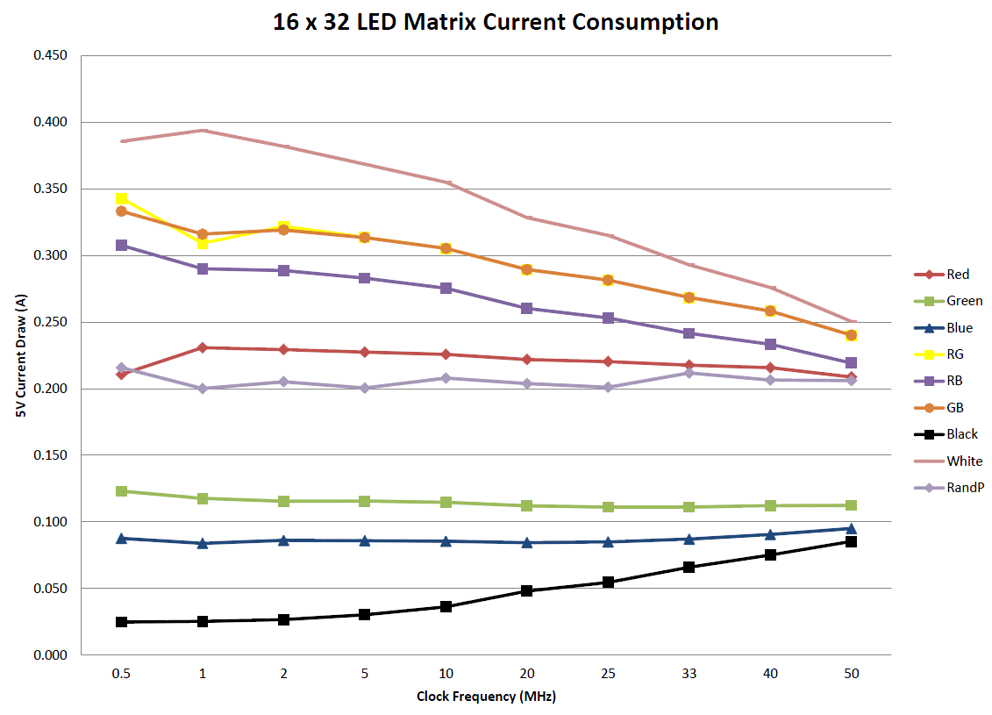

Fig 1. Current draw characteristics based on color output separated by clock frequency. [3]

In terms of monitoring the LED grid power usage, the above image demonstrates values to be expected while running the LEDs. They are always operating at 5V, however their current draw will vary based on the number of lights being illuminated as well as the color and intensity of each particular LED. When the colors are set to purple and orange, the current draw is highest and the lights can expect to be using close to .5 Amps. If the lights were to operate at 5V pulling .5A, then the power consumption would be P=VI = (5)(.5)=2.5W.
- Audio Amplifier
While building our own audio amplifier would have been better suited to the nature of the project, time restrictions and uncertainties made the decision to use a pre-made amplifier a must. The amplifier that we decided to utilize in this case is the TL082 in a simple amplification circuit. The TL082 is the op amp used to modify the incoming audio signals from the Bluetooth device. This device is placed in an audio amplification circuit with an overall gain of 3 and a centered output voltage at 2.5.
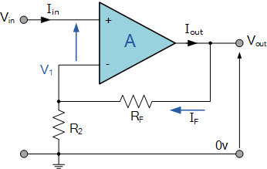

Fig 2. The amplification circuit used in the system that allows for the incoming signal to be in a form that the microcontroller can read and utilize in the code. [4]

The device is required for the system as the Atmega328p in the set-up is unable to generate outputs for analog signals whose voltage comes in below 0V. A gain of 3 is used in order to generate a large sampling size for the Atmega328p to read in while also avoiding clipping of the incoming audio.

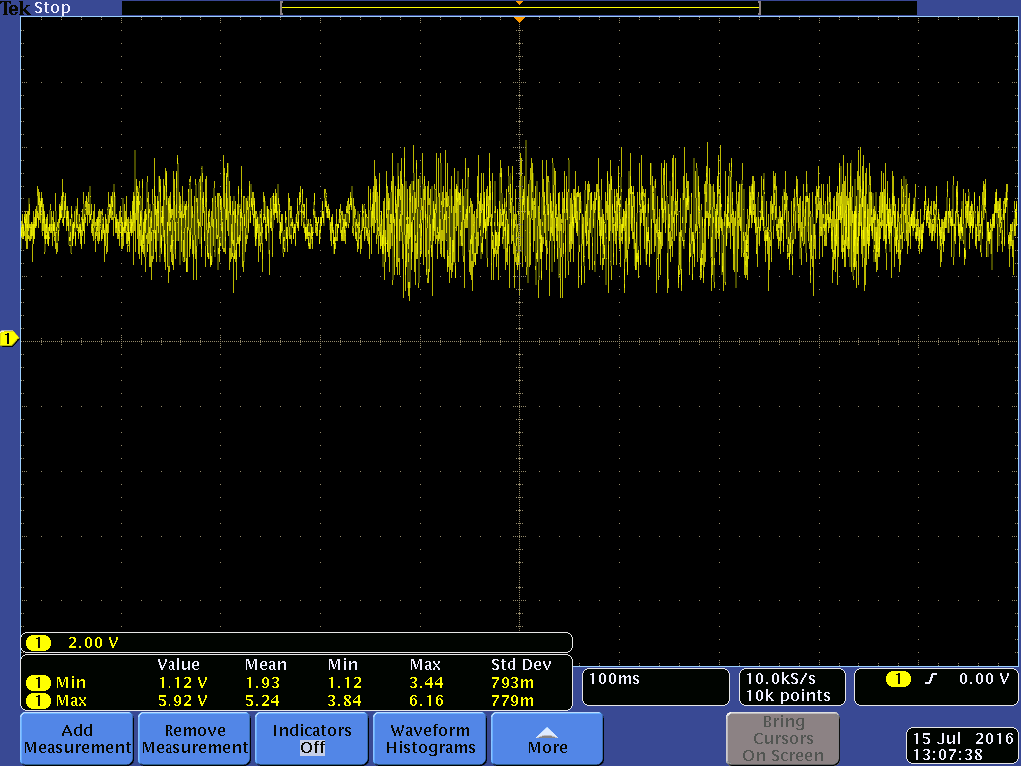

Fig 3. After the audio signal is passed through the amplification circuit, the output voltage is shifted to about 2.5V. The signal is also amplified in a manner to prevent any of the signal from dropping below 0V allowing the Atmega328p to read the incoming data without any issues.

- Power Supply for MCU and Bluetooth Module
The power for the MCU and Bluetooth modules will be supplied by a 9V battery connected to a 7805 Linear Voltage regulator. The regulator will be powered by a 9 Volt battery that is easily accessible to most users. The 7805 wiring is relatively simple in the sense that there is only three connections. There is input connected to positive terminal of 9V battery, there is ground terminal connected to our circuit’s ground, and then the output of the 7805 will be connected to the 5V rail of our system. The primary other components being powered by our 5V rail are the Atmega328p microcontroller as well as the USB Bluetooth audio receiver.

- Bluetooth Module and Audio Splitter
The audio that is received from the handheld device is passed through a dismantled Bluetooth audio receiver module which is then passed through an audio splitter which is another pre-fabricated device These devices were selected in order to facilitate the communication between the two key devices. The devices are also ready out of the box which allows for immediate incorporation to the system for testing. The devices also have standard connection methods (USB and female AUX) which are also easy to incorporate into the design of the system. The design for the audio output amplifier towards the speakers was pre-existing by the speaker manufacturer, because the design area focused on for the Essence of Music was more towards the LED control aspect instead of audio quality. Audio output quality is a whole new realm of electronics that is very in-depth and was not the focus of the Essence of Music.

- Audio Output System
The audio output system is handled by a pair of stereo speakers which receive the input coming from the audio splitter. The speakers take the incoming audio and pass them through a separate audio amplifier which comes from the existing circuitry of the speakers themselves. This is done in order to prevent the system from generating erroneous noise due to a mismatching of hardware components.

III. System Design and Concepts
The design of the system is most easily shown through a basic flow chart detailing the major steps of the main process.
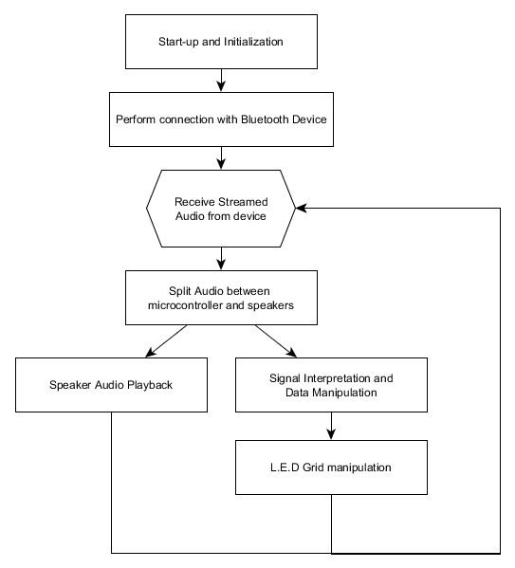

Fig 4. System processes flowchart. The chart shows the major steps in the data receiving process to the L.E.D display.

As the flowchart above shows, the process is generally cyclical in nature. After the handheld device has synched with the Essence of Music device, the loop of receiving data and display and playback of the audio continues until the user terminates the sending of data by disconnecting their device from the system.
- Software Set-up
The start-up phase of the process is simply the powering up state of the hardware that makes up Essence of Music. This step loads the saved code onto the Atmega328p and also preps the remainder of the system components for use. Once the system is plugged in and ready for power consumption, the user simply connects their smartphone or audio player over Bluetooth to the connection titled “PT-810”. Once connected, the user will play music from their audio source and the Essence of Music should begin playing the audio through the speakers whilst displaying lights going along to the music.

- System Synchronization
The next step is the synching of the handheld device to the hardware. This step is done almost entirely through the user’s handheld device. Once the synchronization between the devices is done, audio data is automatically transferred to the device. Once the device is synchronized, the user has two primary control methodologies for the Essence of Music. The first of the two control options are song choice which also includes media buttons such as pausing, skipping songs, and playing previous songs. The second of the control options is volume control which can be controlled on both the Essence of Music’s hardware as well as from the handheld device.

- Signal Separation
The third major step of the process is the separation and interpretation of the audio signals that are received by the system. This is done through the use of a commercial splitter that takes in a single audio signal and splits it up for use in two different locations. After being received, both versions of the signals undergo amplification specific for the following intended use.

- Signal Amplification and Use
The audio signal that is sent to the speaker system is amplified and then broadcast through the use of the built in amplifying circuit. This signal is simply used to broadcast the received audio.
On the other hand, the audio that is sent to the Atmega328p is passed through the TL082 Audio amplification circuit in order to allow for the microcontroller to read in the incoming voltage values. The output voltage is centered on a value of 2.5V with an overall gain of 3 in order to prevent clipping of the signal and provide a wide range of values for the system to work with. The PCB has a voltage divider setup using two 10 k Ω resistors from the 5V rail to the ground rail. The center node between them thus has a voltage of 2.5V and this will act as the center voltage for our audio signal to be processed by our Atmega328p microcontroller. However, the AC signal from the Bluetooth receiver also has to be amplified, so the functionality of a TL082 was utilized in order to increase the voltage range from the Bluetooth receiver. This creates the ideal scenario where the minimum voltage value being output from the audio signal reaches down to 0V and up to 5V. The shift in the output audio signal is due to the fact that the Atmega328p is unable to interpret voltage values that are below 0V, effectively clipping over half of the incoming audio data that we would have access to. This audio data is then transformed into data that the Atmega328p can use to perform calculations and send data to the L.E.D grid for display purposes.

- Repetition of Steps
Of the previous steps, only the first two are not repeated throughout the course of the process. Furthermore, the audio is constantly sent over Bluetooth while the calculations performed on the Atmega328p are performed on a cycle. As such, the display will not show the results of all of the incoming data, but will instead show the interpretations of most of the incoming data.

IV. Primary Software Configurations
The software component of the system is confined entirely to the code that is placed on the Atmega328p. There are three key section of code

- Start-up Section
The first section of code is simply the boot up code for the system. This initializes the L.E.D matrix and also allows for the system to set a specific Baud rate which is 115200 for our system. This section of code runs a single time when the system is reset or started up.
This is accomplished using the following lines of code:
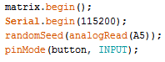

Fig 5. Set-up code that runs once at the beginning of the system start-up.

The code also initializes a button which is used in the switching of patterns externally.

- First Pattern Set
The second section of code is the main pattern modifier of the system. This section of code includes two of the patterns that are used in interpreting the data of the incoming audio signals. There are two basic patterns, each of which prepares to store 32 of the incoming audio signals. These signals are then processed using some basic division to generate visual patterns on the L.E.D grid. The first of the patterns takes in the analog signal and then repurposes it into a value that the system can use. This value is then divided by 64 in order to produce values from 0 to 15. The value of 15 is the maximum since the highest read in value by the Atemega328p is 1023. These values are then fed into the system to determine the height of the L.E.Ds that are lit up. The first pattern takes this value and reproduces the pattern forwards and reverse.

- Second Pattern Set
The second pattern that is used is a rudimentary beat detection pattern. This pattern currently uses a static value in order to determine if a “beat” has been detected and then fills the L.E.D matrix with a single color whenever one of these is detected. The pattern could be improved by using a filter on the incoming audio or by creating a section of code that looks for the largest value incoming from the analog signals and then determining if that value can be used as a “beat” for the purpose of lighting up the L.E.D grid

- Fast Fourier Transform
The third major section of code is the most complex pattern of the system which uses the Fast Fourier Transform in order to interpret the analog data. After Fourier Transform calculations have been conducted, the frequency values will be taken and converted to a 0 to 15 scale, much like from the first pattern set. The height value and entire L.E.Ds below in the column will light up in concordance with the 32 values stored per visual “frame. ” The visual representation will express the “beat” to the audio input. Colors will be given to different peak values within a given spectrum.
The Fast Fourier Transform will take the audio analog input and will convert it into the frequency domain from the time domain. A normal Fourier Transform, or a Discrete Fourier Transform, runs about O(n^2), but the Fast Fourier Transform is capable of reducing the complexity of the Fourier Transform to run at O(n log n). The Fast Fourier Transform will calculate both real and imaginary numbers from the analog input, which is a feasible amount of calculations for the Atmega328p to perform. Due to the RAM available and overall computational power of the chip, running at O(n log n) might potentially still be too much for the chip. To compensate for this, the Fast Hartley Transform was chosen for calculation analysis as it exclusively operates on real data unlike the complex data of the Fast Fourier Transform. The Fast Hartley Transform operates on half the processing power and half the memory as the Fast Fourier Transform, making it far more efficient for the Atmega328p.

V. Device Containment and Dimensions
- Case Dimensions

The entire system will be encased in a case of approximately 25cm x 14cm x 20cm. This will allow for the L.E.D grid to be mounted on the front face of the device and will also allow for the speakers to be mounted on the adjacent horizontal faces. This placement will allow for the system to be rotated allowing the user to rotate the device 90 degrees, positioning the L.E.Ds on either the front or top of the device case.

- Securing Electronics
The electronics will be stored within the case that houses the device. There will be several peripherals located on the side to allow for the user to control several key features. These peripherals include the button which changes the pattern and a knob/dial that allows the user to change the output of the speakers. Within the device, the electronics will be secured to the internal sides of the case using Velcro due to its low cost and Electrical Tape to maintain the integrity of the wiring.

VI. Conclusion

Essence of Music is a simple device that takes in analog signals and processes them to provide the user with a way to enjoy a visual representation of the sounds that they are enjoying. The device will be rather small, being no larger than 25cm in any direction and can be rotated to position the visuals on the top, front or bottom of the device. Incoming analog signals are received from a handheld device via a Bluetooth module and then modified for audio playback and L.E.D interpretation through the use of two different amplifying circuits. The user will then be able to enjoy various display patterns shown to them through the use of an L.E.D grid.

Biographies
Joshua Garber:
Joshua Garber is a senior Electrical Engineering major at University of Central Florida who wants to pursue a career pertaining to the application of reusable batteries for power systems. He plans to pursue an MBA in order to dive into the world of entrepreneurship in the electronics industry. He also enjoys programming microcontrollers to make small parts of everyday life a little bit easier.
Baron Dolletski-Lazar:
Baron Dolletski-Lazar is a senior at the University of Central Florida and will graduate in December 2016 with Bachelor’s of Science of Computer Engineering and a Bachelor’s of Arts and Humanities of French Language and Culture. He plans on pursuing a career that will focus on the reduction of the negative environmental impact technology imposes upon nature.
Nelson Tan:
Nelson Tan is a senior at the University of Central Florida. He plans to graduate with a Bachelor’s degree in Computer Engineering in August of 2016. He plans on pursuing a Master’s Degree in Computer Science and is interested in the field of robot vision and optical studies.

Acknowledgements
The authors wish to acknowledge the assistance and support of Dr. Samuel Richie, Dr. Lei Wei, and the University of Central Florida.

References

[1] Noise-Induced Hearing Loss. (n.d.). Retrieved from http://www.nidcd.nih.gov/health/hearing/pages/noise.aspx
[2] Are Bright Lights Damaging to the Eye? (2015, May 26). Retrieved from http://www.brightfocus.org/macular/article/are-bright-lights-damaging-eye
[3] Burgess, Phillip. "Adafruit Learning System." Adafruit Learning System. N.p., n.d. Web. 15 July 2016.
[4] "Non-inverting Operational Amplifier - The Non-inverting Op-amp." Basic Electronics Tutorials Noninverting Operational Amplifier Comments. N.p., 22 Aug. 2013. Web. 15 July 2016.

